Software: Operating Systems

|  |  |  |
| --- | --- | --- |
| **A** | **Roles of an operating system** | |
| **Memory management** | | Allocation of RAM to all running programs using *paging* and *segmentation*. |
| **Multi-tasking** | | Running several different programs at the same time by switching between them very quickly (*scheduling*). |
| **User management** | | Allowing for different users to have different accounts, security and permissions |
| **Peripheral management** | | Allowing for applications to use peripherals and dealing with interrupts |
| **Utility management** | | Running and maintaining utilities |
| **CPU management** | | Running applications, executing and cancelling processes |
| **User Interface** | | The means of communication between the user and the OS |
| **File management** | | Providing a file system for storage and retrieval of files |
| **Disk management** | | Organisation and maintenance of the hard drive |
| **Library provision** | | Making a range of libraries available. |

|  |  |  |  |
| --- | --- | --- | --- |
| **B** | **Key vocab** | | |
| **Paging** | | Memory management technique which involves splitting RAM up into equal sized pages, and indexing them | |
| **Segmentation** | | Memory management technique which involves splitting RAM into blocks which fit the gaps | |
| **Scheduling** | | The process of arranging and controlling various processes when multi-tasking | |
| **Multi-user** | | When more than one user has access to the same memory, storage or CPU time | |
| **Kernel** | | The part of the operating system which interacts with hardware on one side and applications on the other | |
| **Driver** | | Software which interfaces between applications and peripherals | |
| **Buffer** | | A temporary area of computer memory used to store data for running processes. | |
| **Interrupt** | | A signal to the OS to stop it running its current program, and instead run a particular driver | |
| **Graphical User Interface (GUI)** | | | User interface based around icons |
| **Command Line Interface (CLI)** | | | Text-based user interface |
| **Voice User Interface (VUI)** | | | User interface based around voice |
| **Library** | | A suite of supporting programs which are incorporated into an OS and can be used by apps. These apps will have the same look as other apps on this OS. | |
| **Static library** | | A library where the routines are loaded during translation so they become part of the code. The library does not need to be present on the executing computer | |
| **Dynamic Linked Library**  **(DLL)** | | A library where the routines are loaded during run time rather than translation. The library must be present on the executing computer | |

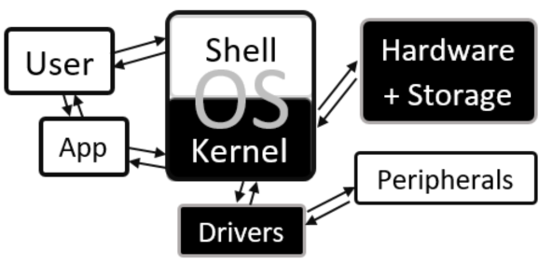

|  |  |  |  |  |  |  |
| --- | --- | --- | --- | --- | --- | --- |
| **C** | **Prior Knowledge** | | | | | |
| Operating System | | Utility | Peripheral | Real time | CPU | System Software |

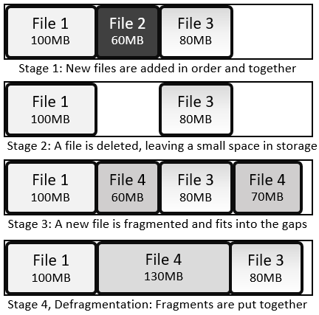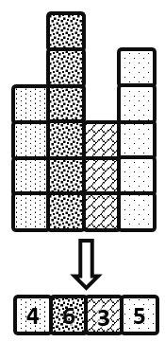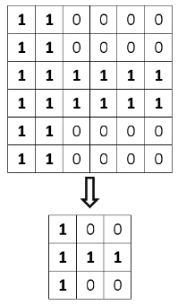

Software: Utilities

|  |  |  |
| --- | --- | --- |
| **A** | **Utilities** | |
| **Anti-malware (software)** | | Software which prevents malicious software entering the system, identifies it when it is there and removes it |
| **Auto update** | | A utility which makes sure the utilities are up to date |
| **Backup** | | A copy of data and programs in case they are lost |
| **Compression software** | | Software which removes redundant data to reduce file size |
| **Defragmentation** | | Reorganise the files on a hard drive so they are all stored together, reducing the time the heads have to spend moving around |
| **Disk check** | | Search the hard drive for bad links and record those areas as unusable |
| **Encryption software** | | Software which encodes data to be stored or transferred |
| **System cleanup** | | Identify and remove unused or redundant files |

|  |  |
| --- | --- |
| **D** | **Prior Knowledge** |
| Operating System | |
| Utility | |
| Compression | |
| Encryption | |
| Malware | |

|  |  |  |
| --- | --- | --- |
| **C** | **Backup Types** | |
| **Full backup** | | All files and folders are copied when backing up |
| **Incremental Backup** | | A full backup is made and from then, only changes are recorded. To restore, start with the full backup and then implement the changes |
| **Differential Backup** | | A full backup is made and from then, only files which are changed or added are saved. To restore, start with the full backup and then update with additional files |

|  |  |
| --- | --- |
| **B** | **Fragmentation and Defragmentation** |

|  |  |
| --- | --- |
| **B** | **Compression** |

|  |  |  |
| --- | --- | --- |
| **A** | **Key vocab** | |
| **Basic Input Output System (BIOS)** | | Software stored in ROM responsible for booting up a computer system |
| **Platform** | | The hardware and operating system for which software is designed |
| **System software** | | Software which is necessary for the running of other software, comprising *utilities* and the *OS* |
| **Operating System (OS)** | | A collection of programs which tell hardware what to do |
| **Utility** | | A single-purpose program for system maintenance |
| **Firmware** | | Software that is stored permanently in a device |
| **Software repository** | | A server which contains open source software which is available for download |
| **Package management software** | | Software which downloads and updates files from a repository |
| **Batch file** | | Series of command line instructions stored in a single file |
| **Run time** | | The period during which a program is executing |
| **Instruction** | | A command that a processor can recognise and follow |
| **Source code** | | A program as it was written in high-level language |

|  |  |  |
| --- | --- | --- |
| **B** | **Legislation** | |
| **Copyright, Designs and Patents Act, 1988** | | Legislation which protects intellectual property by banning its unauthorised copying or redistribution |
| **Computer Misuse Act, 1990** | | Legislation against hacking and disruptive behaviour on computers |
| **Data Protection Act, 1998** | | Legislation which prevents storing of data about an individual which is excessive, unlawfully sourced, unsafely stored or inaccurate. |
| **Freedom of Information Act, 2000** | | Legislation which gives rights for individuals to find out about data held about them |
| **Communications Act, 2003** | | Legislation against malicious communication and using someone's internet without their permission |
| **Waste Electrical and Electronic Equipment Regulations, 2013** | | Legislation regulating the disposal of electrical equipment |

Software: Basics

|  |  |
| --- | --- |
| **D** | **Prior Knowledge** |
| Application | |
| Program | |
| Programming language | |
| Software | |

|  |  |  |
| --- | --- | --- |
| **C** | **Legal and Ethical vocab** | |
| **Open-source** | | Software where access to the original code is available to anyone |
| **Proprietary** | | Software whose source code is kept hidden to avoid loss of profit |
| **Public Domain** | | Intellectual works which are not copyrighted and are free to use |
| **Creative Commons** | | Organisation which issues licences which allow the public partial or total access |
| **Licence** | | A legal agreement about how a piece of software can be used or distributed |

|  |  |  |
| --- | --- | --- |
| **C** | **Legal and Ethical Vocab** | |
| **Copyright** | | A legal right that prevents others from copying or modifying intellectual work without permission |
| **Patent** | | A licence which protects intellectual property |

|  |  |  |
| --- | --- | --- |
| **A** | **Software development stages** | |
| **Analysis** | | Looking at a problem, decomposing it into sub problems, abstracting into essential points and spotting patterns, then writing success criteria for solving the problem |
| **Design** | | Planning the solution to a problem, including pseudocode for algorithms and validation for data entered |
| **Development** | | Practical application of a design and its subsequent development |
| **Testing** | | Making sure a program works under various conditions |
| **Documentation** | | Clear evidence of and information about a product or activity |
| **Evaluation** | | Judgement of the success of a product with reference to the success criteria written in the analysis |

|  |  |  |
| --- | --- | --- |
| **B** | **Types of test** | |
| **Fault Tolerance** | | Testing with illegal or out-of-range inputs |
| **Functional** | | Testing with a selection of inputs which are chosen to be both normal and extreme |
| **Integration** | | After a subroutine has been tested in isolation, testing to see that it works with the main program |
| **Iterative** | | Testing every module before moving on |
| **Parametric** | | Testing of individual subroutines |
| **Regression** | | Testing after any changes have been made to see they have not made unexpected changes elsewhere |
| **User Acceptance** | | Testing with users to see if they interact with the program as expected |
| **Final** | | Functional testing on a high level to make sure the program works as expected |

Software: Development Cycle and Testing

|  |  |  |
| --- | --- | --- |
| **C** | **Testing vocab** | |
| **Erroneous** | | Test data which should not be accepted by a program |
| **Valid / Invalid** | |  |
| **Auto-documentation** | |  |

|  |  |  |
| --- | --- | --- |
| **C** | **Software development vocab** | |
| **Defensive design** | | An approach to programming which tries to anticipate and protect against any problems through a combination of authentication, sanitisation, validation, maintenance and testing |
| **Maintainability** | | The ability for code to be updated and repaired easily |
| **Auto-documentation** | | A programming tool which helps to create summary information about a program |